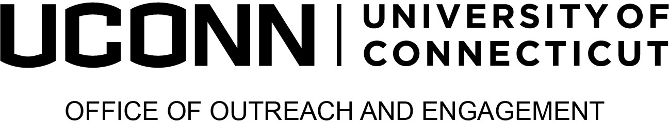

2024 Provost’s Awards for

Excellence in Community-Engaged Scholarship
Institutional Transformation Award
The Institutional Transformation award recognizes individuals, units, or organizations that advance public engagement at UConn at the institutional level. One award will be given to UConn community members or partners for undertaking comprehensive, planned efforts that have transformed UConn’s ability to align research, teaching, practice, and values in service of the common good.

Eligibility: UConn employees (i.e., faculty, deans, staff, or executive) or partners (e.g., UConn Foundation employees, alumni, State employees) as individuals or teams. Individuals or units who have received an individual community engaged scholarship award in the past are not eligible.

Supporting Materials: In addition to submitting this completed form, please include the following with your nomination materials:
- A letter of support from someone other than the nominator, that provides a description of achievement including examples to support claims.
- A summary of the collaborative relationship with University of Connecticut, and the engagement work conducted as part of that relationship. No more than 2 pages

See scope of the application, eligibility and evaluation criteria at s.uconn.edu/EngagementAwards
Nominator Information
Date: | Click or tap to enter a date.
Nominator name: | Click or tap here to enter text.
Nominator’s title and department: | Click or tap here to enter text.
Nominator telephone and email: | Click or tap here to enter text.
Nominator’s relationship to the nominee: | Click or tap here to enter text.

Nominee’s Information
Nominee’s name: | Click or tap here to enter text.
Nominator’s title and organization: | Click or tap here to enter text.
Nominator telephone and email: | Click or tap here to enter text.
Is the nominee aware of the nomination? | ☐ Yes  ☐ No

Nomination Narrative
Please describe how the nominee fulfills the stated criteria. The narrative should include descriptions of specific activities in which the candidate has undertaken comprehensive, planned efforts that have transformed UConn’s ability to increase the quality of societal impact work, comments on the importance of the individual's work to the University, and indicators of the impact of the activities on the external constituent(s) and the University. (No more than 1000 words). Evaluation criteria may be reviewed at https://outreach.engagement.uconn.edu/awards/.
Click or tap here to enter text.

