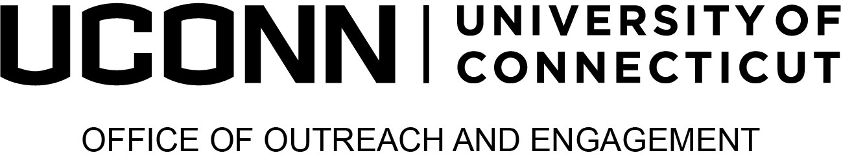

2024 Provost’s Awards for

Excellence in Community-Engaged Scholarship
Faculty Awards

Supporting Materials: In addition to submitting this completed form, please include the following with your nomination materials:
- For individual nominees (faculty, staff, community partner categories)
A resume or CV that summarizes honors, articles, etc. of the engagement work that provides background and addresses the specific award description. No more than 2 pages.
- For individual or team nominations
A letter of support from someone other than the nominator, that provides a description of achievement including examples to support claims.
- For team nominations
A program description (do not include individual CVs of team members). No more than 2 pages
Faculty are also eligible for the Institutional Transformation Awards, please refer to the website for additional details and specific form.

See scope of the application, eligibility and evaluation criteria at s.uconn.edu/EngagementAwards
Nominator Information
Date: | Click or tap to enter a date.
Nominator name: | Click or tap here to enter text.
Nominator’s title and department: | Click or tap here to enter text.
Nominator telephone and email: | Click or tap here to enter text.
Nominator’s relationship to the nominee: | Click or tap here to enter text.

Nominee’s Information
Name: | Click or tap here to enter text.
Title and department: | Click or tap here to enter text.
Department Head or Supervisor: | Click or tap here to enter text.
Telephone and email: | Click or tap here to enter text.
Is the nominee aware of the nomination? | ☐ Yes ☐ No
For Individual Faculty:  Please select the nomination level and categories (see descriptions in page 2) to which you are nominating this faculty. Select one per row. | ☐ Emerging  ☐ Distinguished
☐ Research
☐ Teaching
☐ Community Impact
For Faculty Teams:  Please select the nomination to which you are nominating this team of faculty. | ☐Faculty Team

AWARD CATEGORIES: Individual faculty are eligible for the following award categories at the emerging or distinguished level (except for Institutional Transformation):

Research Scholar Award: The Research Award recognizes faculty who conduct engaged scholarship research—which is defined as a participative form of research that obtains different perspectives of key stakeholders in the process of research design, theory building, problem-solving, or problem formulation.
Instructor Award: The Teaching Award recognizes faculty achievements in community-engaged instruction (e.g., Service Learning and other pedagogical models for partnering with community stakeholders).
Community Impact Award: The Community Impact Award recognizes faculty for addressing critical societal issues that result in impactful, transformational change in communities through activities that align research, practice, and values in service of the common good (e.g., informing life-transformational policy; life-transformative informal educational experiences, increasing access to underserved communities).
Faculty Team Award: The Faculty Team Award recognizes one faculty team for community-engaged scholarship activities. The multidisciplinary team must comprise at least two UConn faculty from different departments/schools. The team's focus can be on research, teaching, or both.
AWARD LEVELS —individual faculty awards for excellence in research, teaching, and community awards may be given at the Distinguished and Emerging levels (Does not apply to Institutional Transformation or Team awards).
Distinguished: Awards given for lifetime, sustained, or career achievements.
Emerging: Awards given for early career achievements.
Faculty Teams are eligible to an award may for their for community engaged scholarship activities with focus on research, teaching, or both.
Nomination Narrative
Please describe how the nominee fulfills the stated criteria. The narrative should include descriptions of specific activities or programs in which the candidate has excelled, comments on the importance of the individual's work to the University, and indicators of the impact of the activities on the external constituent(s) and the University. (No more than 1000 words). Evaluation criteria may be reviewed at https://outreach.engagement.uconn.edu/awards/.
Click or tap here to enter text.

