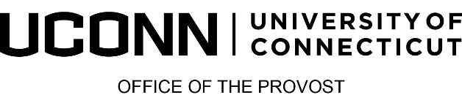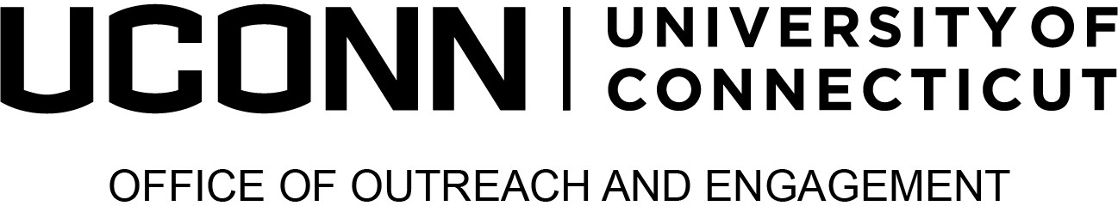

2024 Provost’s Awards for

Excellence in Community-Engaged Scholarship
Community Partners Awards
Community Partner Award: The Community Partner Award recognizes a community individual, organization, or group who has worked collaboratively with the University of Connecticut on community-engaged scholarship activities that demonstrate significant impact.

Supporting Materials: In addition to submitting this completed form, please include the following:
- A letter of support from someone other than the nominator, that provides a description of achievement including examples to support claims.

Community partners are also eligible for the Institutional Transformation Awards, please refer to the website for additional details and specific form.

See scope of the application, eligibility and evaluation criteria at s.uconn.edu/EngagementAwards
Nominator Information
Date: | Click or tap to enter a date.
Nominator name: | Click or tap here to enter text.
Nominator’s title and department: | Click or tap here to enter text.
Nominator telephone and email: | Click or tap here to enter text.
Nominator’s relationship to the nominee: | Click or tap here to enter text.

Nominee’s Information
Nominee’s name: | Click or tap here to enter text.
Nominator’s title and organization: | Click or tap here to enter text.
Nominator telephone and email: | Click or tap here to enter text.
Is the nominee aware of the nomination? | ☐ Yes  ☐ No

Nomination Narrative
Please describe how the nominee fulfills the stated criteria. The narrative should include descriptions of the collaborative relationship with University of Connecticut, the engagement work conducted as part of that relationship, comments on the importance of the individual's work to the University, and indicators of the impact of the activities on the external constituent(s) and the University. (No more than 1000 words). Evaluation criteria may be reviewed at https://outreach.engagement.uconn.edu/paeces-awards/.
Click or tap here to enter text.

